Castle Primary School

Progression of Oracy skills



N.Murphy
2025


What is Oracy?
Oracy refers to the ability to communicate effectively and confidently through spoken language, which is an essential skill for children in Primary education. This encompasses various aspects including the ability to express oneself articulately, engage in discussions and understand others’ viewpoints. In developing oracy skills, children not only improve their speech proficiency but also enhance their listening capabilities, which are critical for collaborative and social interactions within the classroom and beyond. Consequently, teaching oracy is crucial as it lays the foundation for effective communication, critical thinking and social engagement.

The Oracy Framework
The Oracy Framework is built upon three key components: speaking and listening, understanding spoken language and the ability to engage in meaningful dialogue. Speaking and listening skills require children to articulate their thoughts while also being receptive to others’ contributions. Understanding spoken language involves comprehending the nuances of speech, including tone, context and emotion which enriches communication. Engaging in meaningful dialogue entails being able to discuss, question and explore ideas collaboratively. These components work together to enhance children’s overall communication abilities, making oracy a holistic skill.
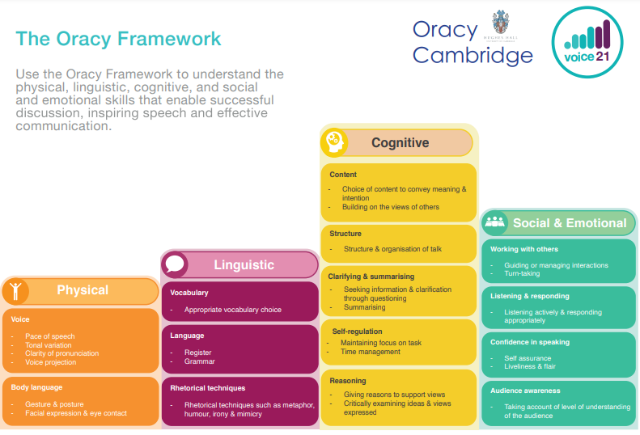
Integrating Oracy across the Curriculum
To maximise the benefits of oracy, it should be integrated across the curriculum rather than taught as a standalone subject. Teachers can weave oracy activities into various subjects, such as incorporating group discussions in history lessons, presenting Science findings and role play. This approach reinforces the use of oracy skills in diverse contexts, helping children to see the relevance of effective communication in all areas of learning.

Supporting EAL pupils in Oracy
For children who have English as an Additional Language (EAL), developing oracy skills requires targeted strategies to ensure they communicate effectively alongside their peers. Teachers can support these children by modelling clear spoken language, providing explicit vocabulary instruction for key terms and allowing for collaborative activities. Group work and partner discussion can also promote language acquisition in a less pressured environment. Creating a nurturing atmosphere where EAL pupils feel safe to practice their speaking and listening is essential for their confidence and growth.

Foundation Stage
Physical
- Speak audibly so they can be heard and understood
- Use gestures to support meaning in play
Linguistic
- Use talk in play and practice new vocabulary
- Join phrases with words such as ‘if’ ‘because’ ‘so’ ‘could’ ‘but’
Cognitive
- Use ‘because’ to develop their ideas
- Make relevant contributions and ask questions
- Describe events that have happened to them in detail
Social and Emotional
- To look at someone who is speaking to them
- Take turns to speak when working in a group

Experiences
- Participate in partner talk during whole class teaching
- Having interactions with other adults around the school
- Provide children with opportunities to speak for an extended period of time about something they are interested in, for example a favourite toy or what they did at the weekend
- Participate in plan, do, review sessions

Teaching ideas
- Provide children opportunities to take on different roles, ensuring they are equipped with the appropriate vocabulary and knowledge to be successful
- Support children’s understanding of turn-taking in talk by having an object to hold
- Support children’s understanding of listening through partner conversations. Break down what is means to listen and frequently return to this
- Introduce new language and sentence stems – My turn, your turn
- Support children’s awareness of the volume of their voices through modelling and chances for them to practice speaking at different levels.
- Build children’s confidence to speak in class by encouraging them to share their ideas

Year One
Physical
- Use the appropriate tone of voice in the right context, for example speaking calmly when resolving an issue in the playground
- Speak clearly and confidently in a range of contexts
Linguistic
- Use vocabulary appropriate to specific tops
- Take opportunities to try out new language, even if not always correctly
- Use sentence stems to link to other’s ideas in group discussion
- Use conjunctions to organise and sequence ideas, for example firstly, secondly
Cognitive
- Offer reasons for their opinions
- Recognise when they haven’t understood something and ask a question to help with this
- Disagree with someone else’s opinion politely
- Explain ideas and events in logical or chronological order
Social and emotional
- Listen to others and are willing to change their minds based on what they have heard
- To organise group discussions independently of an adult

Experiences
- To take part in small group discussions without an adult
- To speak in front of a larger audience

Teaching ideas
- Introduce children to different protocols to scaffold turn taking, for example putting a thumb in when they want to speak or taking turns passing something around a circle
- Use visual aids to support children’s awareness of talk, for example counters to represent contributions to a discussion or passing something from speaker to speaker to show that contributions in a conversation should link to each other.
- As a teacher, explicitly model your own use of questions to clarify your understanding, for example I didn’t understand that, so I’m going to ask myself a question to help me.
- Draw attention to the role that listening has in developing understanding, for example Now that we have heard that, has anyone changed their mind?

Year Two
Physical
- Start to use gesture to support the delivery of ideas, for example gesturing towards someone if referencing their idea, or counting off ideas on their fingers
Linguistic
- Adapt how they speak in different situations according to the audience
- Use sentence stems to signal when they are building on or challenging others’ ideas
Cognitive
- Ask questions to find out more about a subject
- Build on others’ ideas in discussions
- Make connections between what has been said and their own and others’ experiences
Social and Emotional
- To start to develop an awareness of audience, for example what might interest a certain group
- To be aware of others who have not spoken and invite them into a discussion
- Confident delivery of short prepared materials

Experiences
- Speak to unfamiliar people with real purpose
- Participate in a short show and tell session

Teaching ideas
- Introduce sentence stems with accompanying gestures to support meaning for both speaker and their audience, for example linking fingers together for ‘linking to’ and holding up one finger to emphasise their first point
- Create different role play scenarios which enable children to practice speaking in different contexts
- Play games which encourage children to elaborate on their ideas, for example tell me more
- Use hot seating and question tennis to develop children’s questioning skills
- Praise children who invite others into discussions and a class develop how this can be done, for example saying their name, asking them a question, turning to them

Year Three
Physical
- Deliberately vary tone of voice in order to convey meaning, for example speaking authoritatively during an expert talk or speaking with sadness when telling a sad part of a story.
- Consider position and posture when addressing an audience.
Linguistic
- Use specialist language to describe their own and others’ talk.
- Use specialist vocabulary.
- Make precise language choices e.g. instead of describing a cake as ‘nice’ using ‘delectable’.
Cognitive
- Offer alternative opinions to their own.
- Reflect on discussions and identify how to improve.
- Summarise a discussion.
- Reach shared agreement in discussions.
Social and Emotional
- Adapt the content of their speech for a specific audience.
- Speak with confidence in front of an audience.

Experiences
- Take on an expert role e.g. to deliver a talk or speech as an astrologist or archaeologist.
- Become a storyteller for an authentic audience.
- Present to an audience of older or younger students.
- Chair a discussion.
- Hold a class meeting.

Teaching ideas
- Expose students to a range of models for talk, e.g. by meeting an expert or watching a talk. Unpick why each speaker is successful e.g. how they establish their authority.
- Develop a shared language to describe talk in the classroom through creating a class set of ‘discussion guidelines’. These can be used as success criteria to support pupils to reflect on their discussions.
- Introduce ‘Talk Detectives’ to support pupils to reflect on their talk and raise pupils’ awareness of what makes good discussion.
- Spend time teaching pupils what it means to be a chair, e.g. a chair should be prepared to ask probing and clarifying questions and encourage others to do so too.
- Scaffold pupils’ summaries by allocating one student in a trio discussion the role of the ‘silent summariser’. While the other members of the trio discuss an idea, the silent summariser must remain quiet, listen and then feedback the main points at the end of the discussion.
- Play ‘articulate’ with specialist subject vocabulary.

Year Four
Physical
- Consider movement when addressing an audience.
- Pause for effect in presentational talk e.g. when telling a anecdote or telling a joke.
Linguistic
- Carefully consider the words and phrasing they use to express their ideas and how this supports the purpose of talk.
Cognitive
- Give supporting evidence e.g. citing a text, a previous example or a historical event.
- Ask probing questions.
- Reflect on their own oracy skills and identify areas of strength and areas to improve.
Social and Emotional
- Use more natural and subtle prompts for turn taking.
- Empathise with an audience.
- Consider the impact of their words on others when giving feedback.

Experiences
- Speak in front of a larger audience of adults e.g. a group of eight.
- Collaboratively solve a problem.
- Receive feedback from a peer or audience member on their oracy skills.
- Create TV/radio programmes.
- Mock election hustings
- Peer teaching
- Perform poetry by heart

Teaching ideas
- Introduce pupils to sentence stems to cite evidence and ask probing questions.
- Teach the conventions for different types of talk, e.g. in oral storytelling using similes, metaphors, time connectives, rich description and techniques to build suspense. In a persuasive pitch using a ‘hook’ to grab the audience’s attention, rhetorical devices such list of three and rhetorical questions.
- Create opportunities for pupils to reflect on their own oracy skills, and those of their peers, and set targets for improvement.
- Set up discussions where each pupil has key information to bring to the discussion. E.g. each pupil has read a different historical source or piece of evidence and the group needs to decide the cause of the central event.
- When using trio discussions, allocate one member of the trio the role of questioner. Their sole responsibility during the trio discussion is to ask questions of the rest of the group.

Year Five
Physical
- Project their voice to large audience.
- Gestures become increasingly natural.
Linguistic
- Use an increasingly sophisticated range of sentence stems with fluency and accuracy.
- Develop an awareness of collocations.
Cognitive
- Draw upon knowledge of the world to support their own point of view and explore different perspectives. E.g. In a discussion about vegetarianism, rather than saying ‘my mum is a vegetarian so eating meat is wrong’ to be able to say ‘lots of people don’t eat meat because they believe killing animals is cruel’.
- Identify when a discussion is going off topic and bring it back on track.
Social and Emotional
- Listen for extended periods of time.
- Speak with flair and passion

Experiences
- Enter a debate competition
- BBC school report
- Create a podcast
- Meet professionals e.g. a lawyer, an MP or councillor to ask questions about their job.
- Compere a school talent show or event.
- Slam poetry/ Stand-up comedy

Teaching ideas
- Equip students with the language to describe when a discussion has gone off track and support them to identify when this has happened e.g. by looking at transcripts or video examples.
- Develop sentence stems for students to bring discussions back on track e.g. ‘That might be true, however what do you think about X?’ ‘It feels a bit like we are going off topic here. Let’s get back to X’.
- Teach strategies to be able to listen for an extended period of time, e.g. note-taking or drawing visuals.
- Use vocal warm ups and diaphragm breathing exercises to support voice projection. Some examples are in the book, This is a Voice.
- Develop a bank of sentence stems which have a similar meaning to those students are already familiar with e.g. for agreement: ‘I agree and I would like to add …’ ‘I would like to echo what X said because …’ ‘I see it in a similar way to X because …’ ‘I have a similar opinion because ...’.

Year Six
Physical
- Speak fluently in front of an audience.
- Have a stage presence.
- Consciously adapt tone, pace and volume of voice within a single situation.
Linguistic
- Vary sentence structures and length for effect when speaking.
- Confidently use idioms.
Cognitive
- Construct a detailed argument or complex narrative.
- Spontaneously respond to increasingly complex questions, citing evidence where appropriate.
Social and Emotional
- Use humour effectively.
- Read a room or a group and take action accordingly e.g. if everyone looks disengaged, moving on or changing topic, or if people look confused stopping to take questions.

Experiences
- Give a speech to an audience of peers and adults
- Mentor or teach younger students
- Lead an assembly
- Act as a tour guides for prospective parents
- Record a sports commentary
- Create mini-documentaries including interviews with ‘experts’

Teaching ideas
- Play games like ‘just a minute’ to practise fluency when talking about a given topic e.g. climate change.
- Practise ‘power poses’ to explore physical aspects of speaking.
- Teach structures for building evidence based arguments.

